@Body(‘param_name’) : to fetch property from JSON request.

DTO: Data Transfer Object

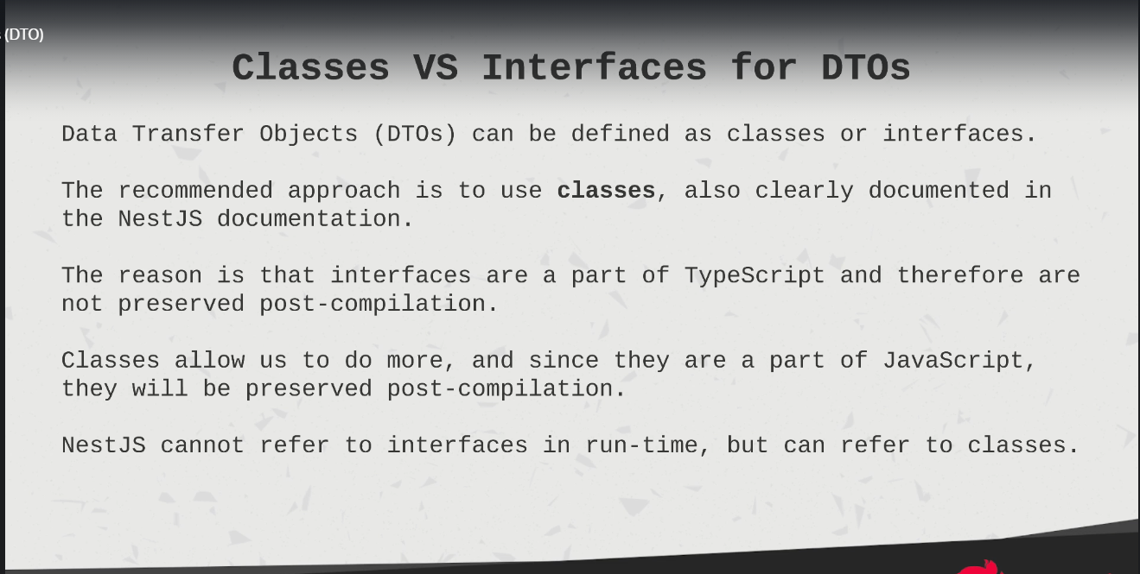

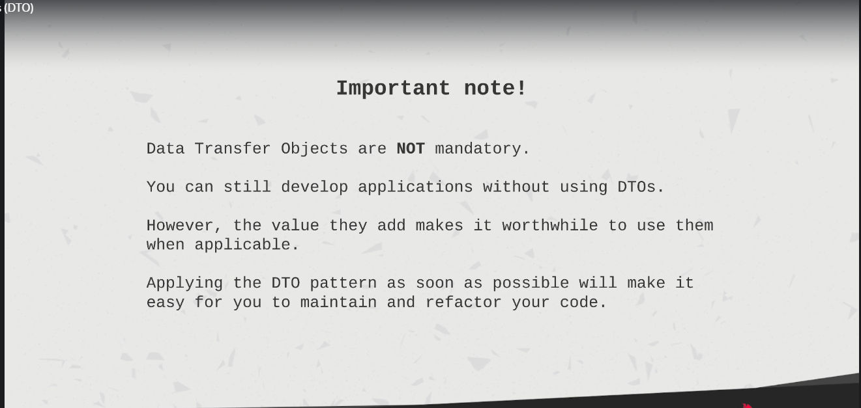

@Param(‘param_name’)

@Get('/:id')

  getTaskById(@Param('id'))

@Query() object: ObjectType => to get query string by key value

**Error Handling:**

**Pipes in NestJs:**

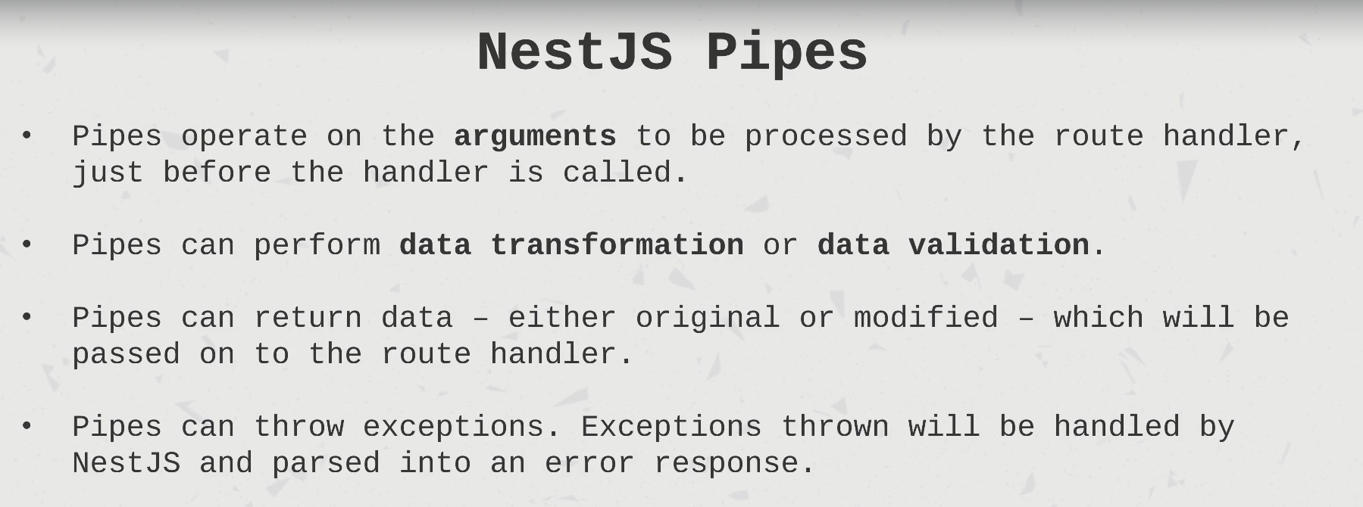

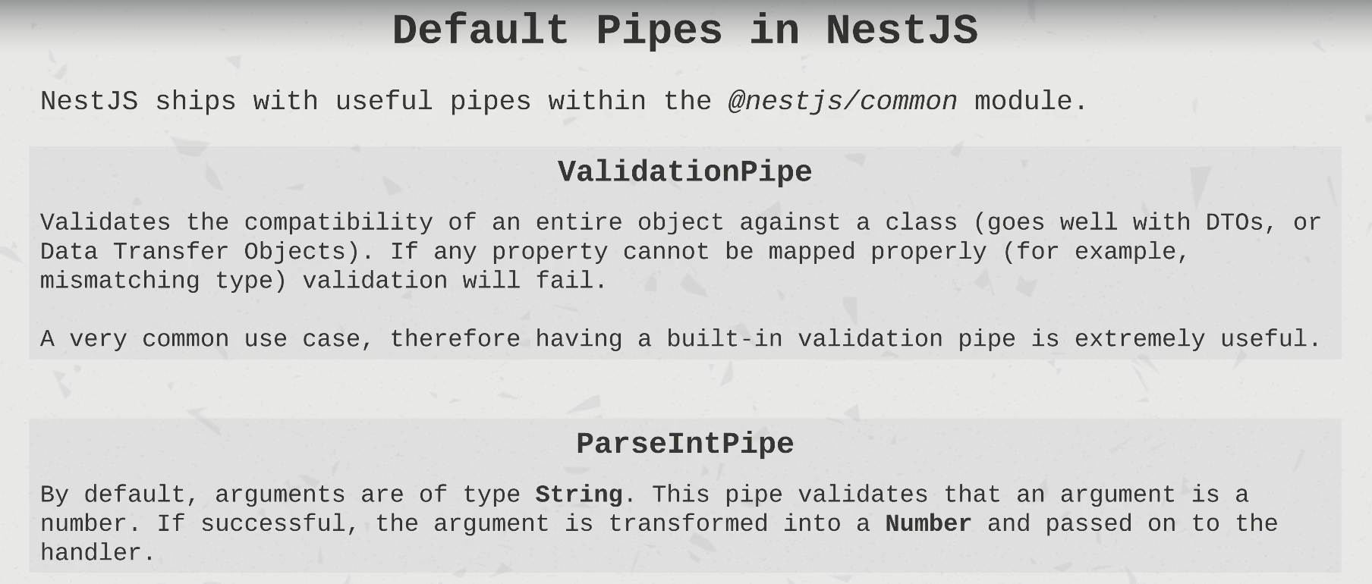

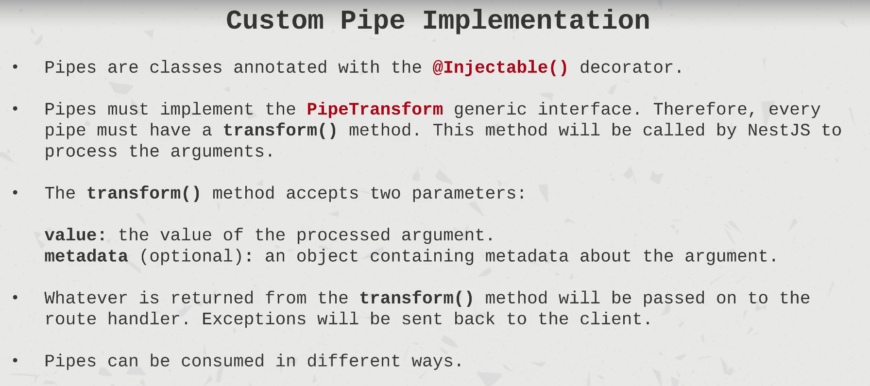

**Types of Pipes:**

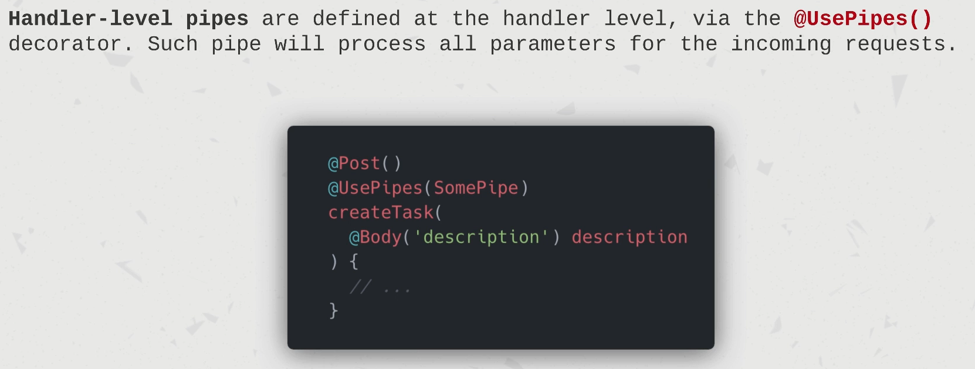

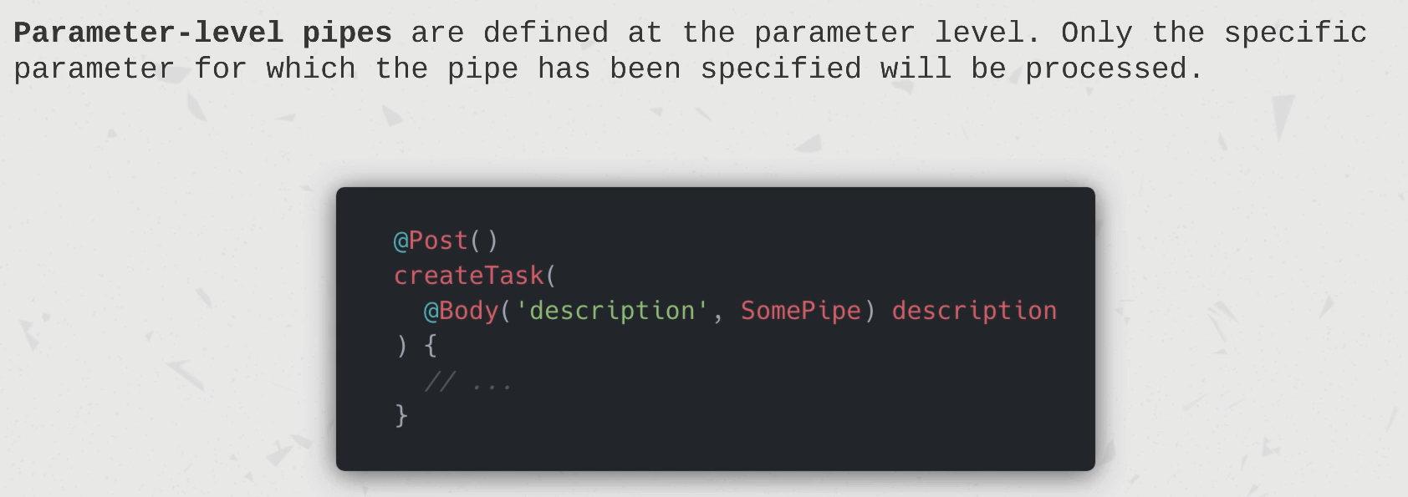

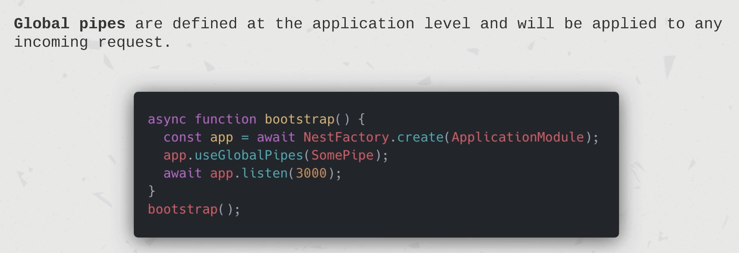

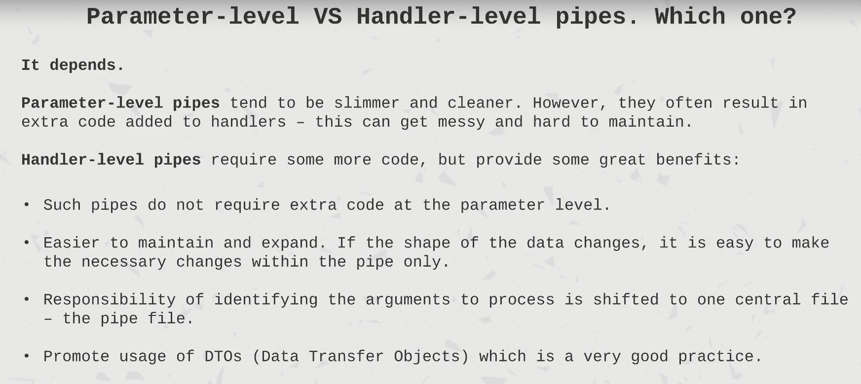

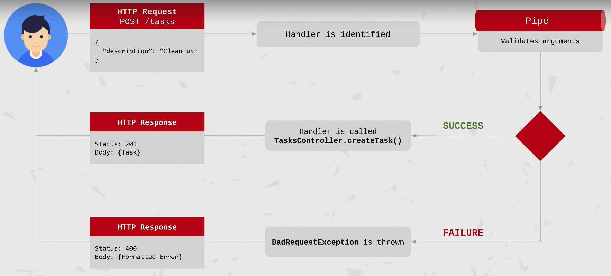

**Pipes packages :**

**Npm install class-validator class-transformer**

**Ex:**

**import { IsNotEmpty } from "class-validator";**

**export class CreateTaskDto {**

**@IsNotEmpty()**

**name: string;**

**IsNotEmpty()**

**description: string;**

**}**

Import

**app.useGlobalPipes(new ValidationPipe)**

**Using pgAdmin and TypeORM lib further for data persistence:**

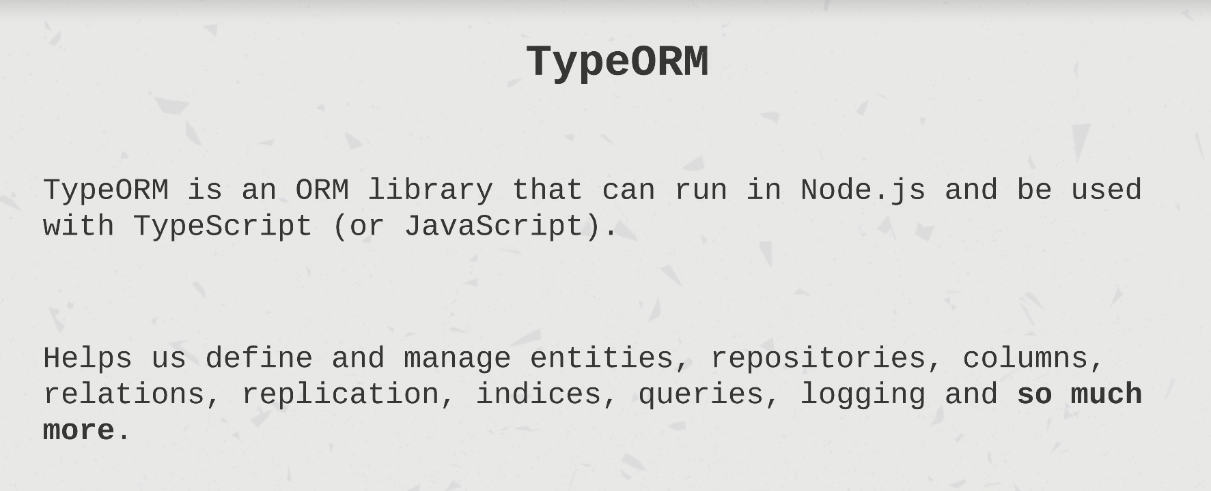

Npm install typeorm @nestjs/tyorm pg

Logging rules

